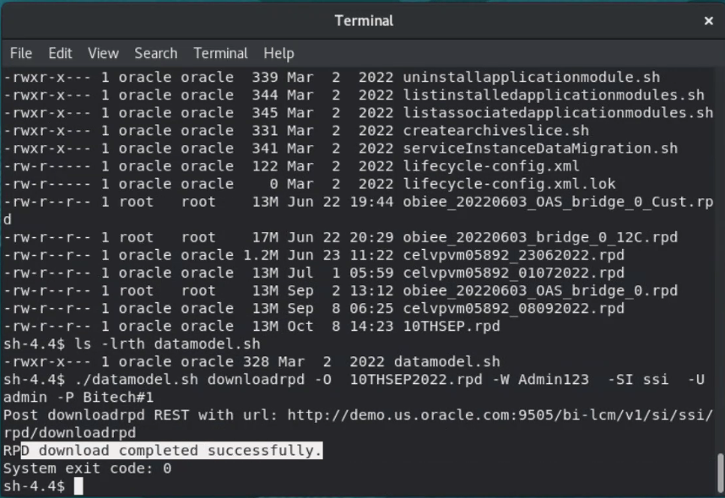

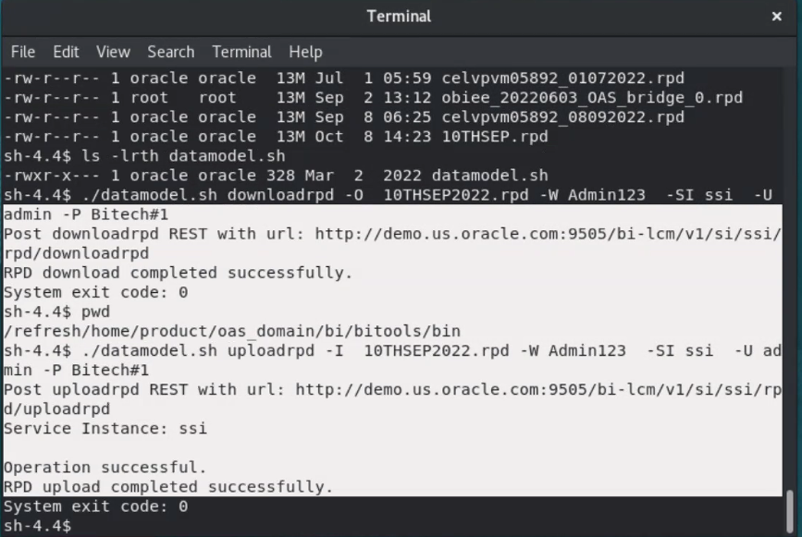

* -SI the OBIEE service instance, e.g. ssi
* -O obiee.rpd – is the name of RPD will be saved in the current directory.
* -U weblogic – is the username.
* -P oracle123 – this is the password for user weblogic used to login on OBIEE

References:

<https://docs.oracle.com/middleware/12212/biee/BIEMG/GUID-C0BBA452-CC54-43A3-9A61-F1ADCCBEBDDB.htm#upload_repos_cmd>

How to deploy RPD in OBIEE 11g

Steps:

* Login Entereprise Manager (/em)

